OC Boat Handling and Care
General Policies-
- Club boats are for NCAWPA members only.
- Small boats are to be used ONLY by current NCAWPA members who are certified.
Ramifications:
- If you're not a member, you can't use small boats. Please go to novice night.
- If you are a member and know someone who is not a member using the club boats, inform them that the small boats are for certified members.
- Club members are NOT allowed to take non-members in a club OC2 boat with them.
- People who are certified are NOT allowed to take a non-certified person with you in the small boats.
- Newly certified members must be with a partner on the water for 12 months and use two people to carry the boat for safety/accountability reasons
- Always HAVE a PFD and whistle
- Follow the 100-degree rule (combined air and water temperature must be above 100 degrees)
- It is encouraged that you carry a cell phone or let someone who knows where you are and when you are expected back.
- If you are paddling alone it is strongly recommended that you wear the PFD
- Inflatable PFD’s must be worn to meet legal requirements
- Failure to follow any of the NCAWPA small boat rules when using a club boat has consequences. Normally, the first violation of club policy will lead to a written warning and reminder of club policies. Repeated violations or major violation may result in loss of small boat privileges and/or loss of club membership.

Boat sign-out and Handling:
- Damage results in lack of boat availability- These are our club boats, they're not your boat - treat them as if you are a guest
  - OC1/2 replacement cost - $4000+ OC1, $5000+ OC2
  - Repair cost - $85/hr
  - Small boats are large, unwieldy, fragile, and expensive
  - Review club policies which are posted
- There are private boats; they are not for member use. You are responsible for knowing which boats are club boats. Club boats have stickers with NCA, they also have a number on them, and they are on the sign out sheet.
- You must sign up online beforehand to use a small boat. Member can sign out a club boat up to 3 times per week.
- You may sign up as early as 7 days before the date/time. Decide which boat you want to use - club boats have NCA written on them AND have numbers.
- If you want to do a last-minute paddling session, check online first. If a boat has not been signed out, then it is up for grabs. But someone else might have the same idea, so be prepared to arrive and find no boats are available.
- Sign-out for club boats here: https://docs.google.com/spreadsheets/d/14lU3650adhNChPidOng5t2O5Aons7NfmX5WF_EFHwZA/edit?usp=drivesdk
- When you arrive at the boat house, check the boat- make sure the boat you plan to use is available and in working order: vents, ama, iakos, (damaged boats will be indicated as such in the sign out sheet), examine the boat to make sure it is sea-worthy, you will be in a world of hurt if it's not.
- Club boats may be used for races. Follow club policy to reserve the boat and once approved, sign it out on the sign out sheet.
  - When transporting club boats, V-bars with ama holders are to be used. The club has 3 V-bar set ups available to club members. They may be reserved when you reserve the club boat.
    - Anyone preferring to use an alternative set up must get their setup approved by the NCAWPA board prior to transporting a club boat.
    - V-bars must be used for cars – approval will not be granted by the board for alternative set ups. The crossbars in cars are too close to safely secure and transport a 20+ foot OC.
    - Board approval of an alternate rack system must have occurred after the purchase of the V-bars in 2018.

Moving the boats-
- check that the dock is clear
- take paddle and PFDs to the dock
- two people hands on the boat (one person carrying is much later, go through at least one year of two-person carries before you are ready for that)
- be careful of all the boats around you and the racks themselves as you're pulling out your boat: goal is no contact with anything -- eg. watch the amas of the boats above and below, make sure your boat's 'iakos aren't hitting those amas
- balance is key
- communicate with each other all the time
- the boat is longer than you think and the ama sticks out farther than you think
- corners must be turned wide
- watch the doors as you're coming out of boathouse
- walk straight out farther than you think before you turn
- watch the telephone pole
- watch the railings on the ramp
- hull on dock with rudder over edge
- one boat first, then the other, both people carrying both boats
- shut the bay door and lock it
- PFDs attached to the boat (or your body), if you are paddling alone you should wear the life jacket
- attach leash, wear at all times
- one person in, then the other. Take care when reaching for your paddle – keep it close enough so that you don’t have to leave over to grab it.

On the Water
- watch for clear water - floating debris and snags WILL damage the boat and rudder.
- river traffic patterns - stay to the right, know which arch to go through- there are charts on the wall at the front of the second bay of the boat storage building.
- Know what/who to watch for, bridge rules, rowers can't see where they are going
- the rudder is longer than you think
- if you hit something with the front of the boat, stop immediately so you don't hit the rudder
- Use logic and common sense for turning, especially in the wind- avoid turning ama-side first into the wind when possible.
Returning to the boathouse
- one person out, then the other
- hull on dock with rudder over edge, be care with the drainage holes
- remove leash
- remove PFDs from boat
- get two sets of slings out of the boathouse, set them up in the yard
- get at least one PFD for each ama and lay it on the ground near the slings
- two people hands on the boat
- carry to slings, avoiding contact with everything, communicate with each other
- set boat in slings
- wash boat with hose
- turn the boat over
- wipe down with towels
- check for damage anywhere and everywhere
- two people hands on boat to storage rack
- get lined up in the yard before going through the door
- avoid contact with everything
- straight into the boathouse
- walk all the way until you're lined up with the rack
- straight into the rack, avoiding all contact
- make sure ama is resting on the rack
- make sure iakos are not hitting the rack above
- shut the bay door and lock it
Huli drill
- hold on to your paddle
- hold onto the boat
- Slight lean to the right to huli.
- Turn the boat upright – get on the non-ama side, reach over and grab the iako and pull it over in a controlled manner.
- Get back on the boat-
- Get between the ama and boat.
- Easiest way to get on is to put the left hand on the back iako and the right hand on the back of the seat and press yourself up until your butt contacts the seat. Then bring the feet in. Alternatively, you can belly flop on, but this can be difficult if you are wearing a PFD.
- Remove leash, untangle it and re-attach it to your foot.
- Either way, be sure to keep leaning to your left. One small lean to the right and you are going to huli again.
- Hand paddle if you lost your paddle.

Notes on Navigation Markers-

Most important thing to remember- these mark the channels for power boats and sail boats. It is good to avoid being in the channel in an OC-1 or OC-2, as bigger boats always have right of way, may not see you, and will cause serious damage if they hit you.

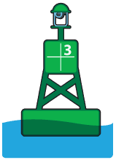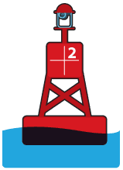

GREEN LATERAL MARKER - Should be kept on your left (port) side when proceeding in the upstream (returning from sea) direction.

RED LATERAL MARKER - Should be kept on your right (starboard) side when proceeding in the upstream (returning from sea) direction.

RED & GREEN LATERAL MARKER - May be passed on either side when proceeding in the upstream direction. The main or preferred channel is indicated by the color of the topmost band.

The area located between a red and green lateral buoy is the navigable channel.

NUN BUOYS CAN BUOYS DAY MARKS
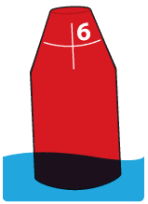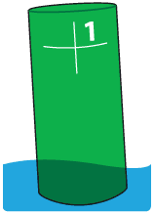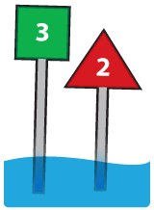
Red cone-shaped markers. Keep this marker on your right (starboard) side when proceeding in the upstream (returning from sea) direction.
Green cylindrical-shaped markers. Keep this marker on your left (port) side when proceeding in the upstream (returning from sea) direction.
Red triangles with even numbers are the equivalent of nun buoys (keep this marker on your right). Green squares with odd numbers are the equivalent of can buoys (keep this marker on your left side).
The numbers that are fixed below day-marks indicate the distance (in miles) to the river mouth.

THE UNIFORM STATE WATERWAYS MARKING SYSTEM

INFORMATION MARKERS (SQUARE)
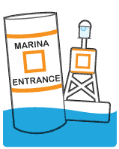
Display information, such as localities, marinas campsites, etc.

HAZARD MARKER (DIAMOND)
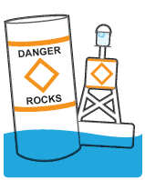
Mark random hazards such as shoals and rocks.

CONTROL MARKER (CIRCLE)
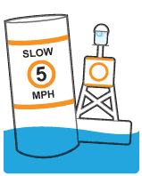
Indicate speed limits, wash restrictions, etc.

KEEP-OUT MARKERS
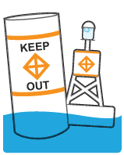
Indicate areas where boats are prohibited.

OBSTRUCTION MARKERS
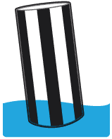
Indicate an obstruction to navigation. Do not pass between this marker and the shoreline.

MOORING MARKERS
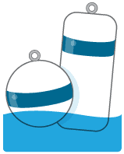
Used for mooring or securing vessels.

